Subroutines are not only limited to passing individual fields. You can also pass internal tables as well as a combination of individual fields and tables.

Just remember you've always got to get the sequence of fields correct when you're passing fields and internal tables from the main program to your form. Because it's the sequence of the fields when you create your perform statement that determine which field is passed to the interface variable of your form.



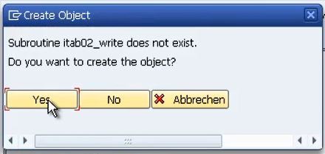

And instead of having the using addition, what we do is include tables followed by the table we want to pass through.

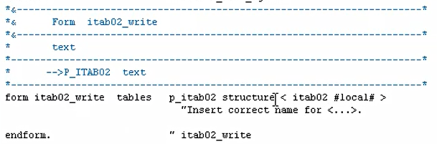

This code here is not actually needed, so we can remove that, and we'll just focus on the basic form of how it's generated, our subroutine.

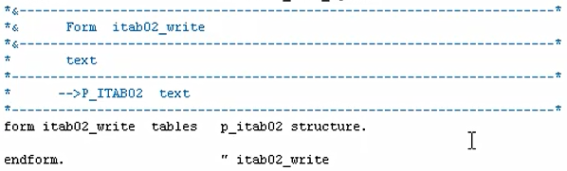

there's a fundamental change that's gone on here. We have replaced the Using edition with the Tables edition. So now when the program is executed, the perform statement ensures the contents of our internal table that transferred to the sub-routine installed in the internal table P_itab02.

Once processing reaches the end of the form, the contents of the local internal table are then passed back to our global internal table. And just know this is for a table without a header line.

If we are using the older techniques of passing tables with header lines and this perform statement structure that we've just declared Up here, would only pass the headline of the internal table to the sub-routine.

To be able to pass the whole table contents when using an internal table with a header line, you need to use square brackets.



Now when an internal table is passed into this subroutine, this local internal table is always declared with a header on.

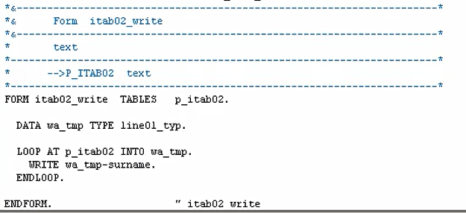

We'll have a look at our itab02 table in sub routine.

You can see it's got five records in, and we can see it's the newer style, internal table, because we've got no header record.

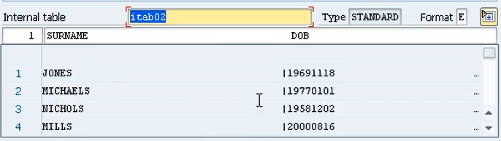

And if we have a look at this p table.

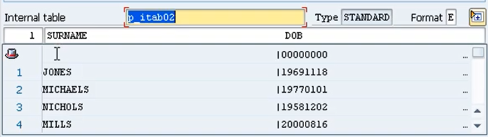You can see here we got the hat sign, and you can see we have a header record. It's the old style.

But being good coders, what we've done we've made sure we've used a brand-new work area when we're looping through our local copy of the internal table.